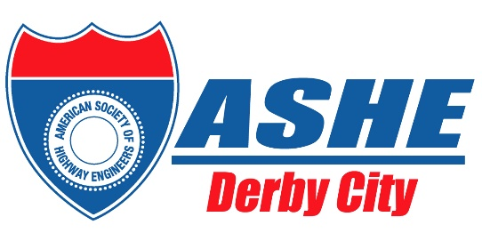 | American Society of Highway Engineers  Derby City Section
2026 Academic Awards Program

AWARDS

The awards will be presented by the American Society of Highway Engineers Derby City Section (ASHE Derby City) each year to an eligible University of Louisville, Speed School of Engineering Junior, Senior, or Graduate Student (successfully completed 60 or more credit hours prior to applying) who is enrolled in a transportation major, for the Spring semester, of the award year, and lives in Kentucky or Southern Indiana.

PURPOSE

The purpose of the academic awards is to promote the continuing education of University of Louisville Speed School of Engineering upper classmen in the study of transportation related diplomas and encourage their involvement in transportation related careers. Award applicants must meet one of the following criteria:

- Be classified as a junior, senior, or graduate student at the University of Louisville Speed School of Engineering (successfully completed 60 or more credit hours prior to applying), with an emphasis in Transportation, or other related fields, as approved by the ASHE Derby City Board of Directors. Also, the above-mentioned student, cannot have previously won the ASHE Derby City Scholarship.

SCOPE

Applicants must complete and submit the academic award application by May 1, 2026, for notification of award by June 2, 2026. Awards are presented on a one-year basis. The annual maximum individual award is $2,000. The ASHE Derby City Board of Directors annually sets the amount and number of awards.

OPERATION/STUDENT REQUIREMENTS

- Applications in digital or hard copy, from interested individuals, will be emailed or mailed to the ASHE Derby City Scholarship Committee Chair.

- Selection Criteria for award recipients will be based on the following guidelines:

  - Extracurricular & Volunteer Activities; Employment
  - Honors
  - Personal Narrative
  - Character References
  - Transcript

- At the conclusion of the selection process, all applicants will be contacted and the students who are chosen to receive the awards will be informed.

- No later than one month after selection, the Scholarship Committee will mail a check to each recipient to assist in payment of tuition, books, or fees for that school term.

- Recipients of awards from the ASHE Derby City Section may accept scholarships from other sources.

- ASHE Derby City Section does not assume any responsibility for the conduct, personal affairs, or debts of the award recipients or applicants and shall not be liable, therefore, in any manner.

- Applicants must remain a qualified student in good standing of the general requirements within the University of Louisville Speed School of Engineering.

REMIT APPLICATION on or prior to May 1, 2026, to:

Durbin Richardson
ASHE Derby City Scholarship Committee Chair
435 N. Whittington Parkway Suite 200
Louisville, KY 40222
E-Mail: durbin.richardson@burgessniple.com
Secondary E-Mail: donna.hardin@ky.gov
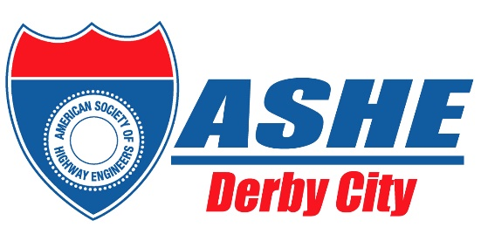 | American Society of Highway Engineers  Derby City Section
2026 Academic Awards Application Form

The awards will be provided by the American Society of Highway Engineers Derby City Section (ASHE Derby City) each year. The awards will be presented to applicants who classify as juniors, seniors, or graduate students at the University of Louisville Speed School of Engineering (successfully completed 60 or more credit hours prior to applying).

Awards will be made in consideration of scholastic, extracurricular and volunteer activities, record of employment, honors, personal narrative, references, transcript, and on the content and appearance of the application. The awards may be used for any transportation engineering education related expense.

Applications must be submitted either by hard copy format in the mail, postmarked no later than May 1, 2026, or by digital format via email by 11:59 PM, May 1, 2026, to the American Society of Highway Engineers Derby City Section Scholarship Committee Chair.

(Late Applications will not be considered.)

PART A: Biographical Data (Information must be complete to be considered.)
Student’s Full Name:
Current Address in Kentucky or southern Indiana Including Zip Code:
E-Mail Address:
(Will be used only for contacting applicant, not for solicitation.)
Phone: |  |  |  | County of Residence:
Classification : |  |  |  |  | GPA:
(Junior, Senior, Graduate Student)
* Please attach transcript

PART B:

Please attach a brief summary of your activities and work experience; include school, community, church, etc. List any positions of responsibility held and any honors you received.

PART C:

Please attach a letter of recommendation from one of the following sources: a teacher, school counselor or administrator, professor, instructor, or supervisor in a work environment.

PART D:

Please attach a brief statement describing your reason for applying for this scholarship award and a brief written statement which includes your plans for the future, your career and life goals. Include why the field of Transportation is important to you, your hometown, and/or to our country.

I declare that all information reported herein is true, correct, and complete.

Applicant’s Signature: Date:

